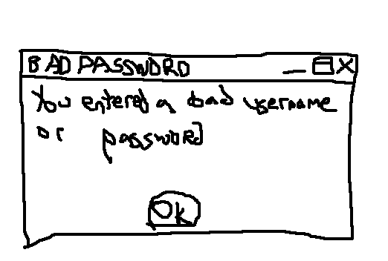
I cannot show a screenshot of the failed login due to the fact that Windows doesn’t keep the clipboard on the login screen. I also cannot show a screenshot of the event log due to the fact that I lack permission to do so. So I suppose that this will have to suffice. It doesn’t really surprise me that much though. I mean, I mistype my password all the time. I see this dialog quite frequently. I agree with this setting on this workstation; I shouldn’t be able to see this stuff. I’d be surprised if I could do it.

